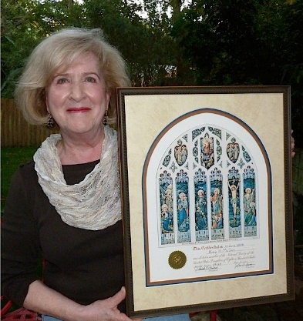
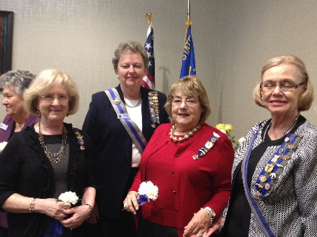
Next Meeting…..
Saturday,
October 24
Buton Memorial Library
Plant City
Kay McGee with her certificate
Did you know…?
England tried to gain Florida from Spain during the War of 1812.
One of the last known battles of the War of 1812 was fought at St. Mary’s near Jacksonville, Florida. The fight began on Dec. 22, 1814 and lasted until Jan. 8, 1815. It became known as the Battle of Point Peter.
Officers 2015-2017
President- Rhoda Garcia
Vice President -Ramona Glenn
Chaplain –Betty Glenn
Recording Secretary –Sheila Smith
Treasurer------Jeanette Frey
Registrar- Karen Wolzanski
Historian –Roberta Flowers

With summer barely underway, our first meeting in October seems a long way off. However the Chapter Offices and committee chairs will be working through the summer to insure another successful year. We look forward to the fellowship we all share at our meetings and events.
There are so many demands on our time and pocketbooks today that we can’t possibly do everything and support everything. If you have a particular interest in one of our USD 1812 projects and would like to make an extra contribution to that project, please add it to your dues remittance. Even if it is $1.00 it will be appreciated. If you choose to do that please let Jeanette know what the contribution is for.
We all contribute to our wonderful society by our interest and membership in the USD1812. Our time is a contribution that we all make when we attend meetings, award JROTC medals, attend grave markings and other recognition of historic events or makers.

In This Issue………
Treasurers notice……………….2-3
Committees ………………………….4
Officers 2015-2017………………..1
Insignia Orders...…………………….6
Note to Chapter members…….5
Benjamin DeVane
Chapter Newsletter
June 2015

Florida State Society Meeting in Orlando
Feb. 2015
Kay McGee, Rhoda Garcia, Roberta Jordan, Helene Werner, Michigan State Society in back.

BENJAMIN DEVANE CHAPTER USD 1812

June 1, 2015

Dear Members of Benjamin DeVane Chapter:
It is that time of year again and chapter dues are being collected.
As your treasurer, I am requesting that you send in your dues to my address below. I will greatly appreciate it if you would send in your dues by July 1st. Then I will be able to make the necessary deposits and send the information to State and National.
The total dues amount is $36 for Adult membership and $4 for Junior members. Any donations are greatly appreciated.

Thank you and have a wonderful summer.

Jeanette J. Frey
Benjamin DeVane Chapter Treasurer

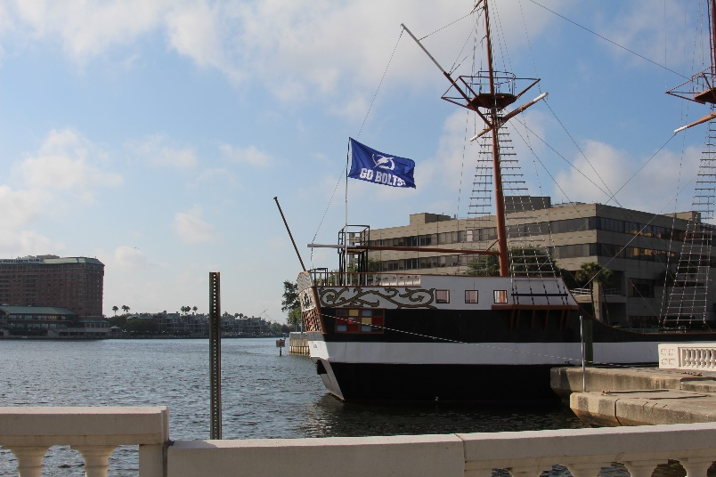

Figure 1Tampa’s ship the Jose Gaspar says “Go Bolts”

Committees USD1812

American Merchant Marine Library Karen Wolzanski
Ancestor Plaques Bev Gentry
Budget and Finance Jeanette Frey
Flag House and Star Spangled Banner Museum Bev Gentry
Fort McHenry Roberta Flowers
Markers and Graves Locations of 1812 Personnel Kay McGee
National Defense Michelle Hubenschmidt
Newsletter Editors Rhoda Garcia, Kay McGee
Junior Membership Rhoda Garcia
Old Fort Niagara Jennifer Marks
Public Relations Frances Nettles
Schools Betty Lambert
Veterans Rehabilitation Becky Bandy

Many chapter members enjoy wearing their USD 1812 pins to chapter meetings and at events sponsored by the National Society, Florida State Society or local chapter events.
Summer is a good time to consider ordering pins you might want as the official jeweler, Hamilton Jewelers, is not as busy this time of year. Orders can take several weeks to process.
For your first order Hamilton will send your pins to you placed correctly on the ribbon. Later newsletters will have more on correct placements of pins.
Many of us also enjoy wearing branch bars with mini –insignia from our other Societies. Hamilton also sells the branch bars and mini insignia.
According to the National Handbook of the Society, p. 32 “The popular “Branch Pin” may be worn to the official meetings of the Society or sponsored events, but only on the right shoulder and never pinned to a sash of office”.

